|  |  |  |
| --- | --- | --- |
| BUSINESS UNIT  CUSTOMER CARE | | |
| TITLE  **Escrow Tax (Call Center)** | | PROCESS OWNER:  Garrett Browne |
| VERSION  1 | DOCUMENT ID  FSPID-1989020554-1782 | APPROVAL DATE  [Approved (Compliance)] |
| APPROVED BY:  Matt Harbus | | LOB APPROVED DATE  9/11/2023 |
| CURRENT STATUS:  Published | | NEXT REVIEW  [Next Review/Due Date] |

TABLE OF CONTENTS

**Overview** 2

**Job Aid** 2

Taxes 2

**Appendix** 25

**OVERVIEW**

The purpose of the **Escrow Tax (Call Center) Job Aid** is to provide guidance to the Customer Success Specialists (CSS) and Single Point of Contact Specialists (SPOC) as they work with customers regarding escrow taxes. This guidance includes working with our vendor, CoreLogic, in the processing of tax bills as well as helping our non-English speaking customers by using our interpretive vendor, TransPerfect.

Specialists also receive guidance on processing Customer Inquiry Trackings (CITs) in the Servicing system of record, LoanServ, and in reviewing property tax reassessments, supplemental tax bills, and other documentation stored in the Electronic Document Management System (EDMS).

**JOB AID**

TAXES

# Taxes

* 1. Customers who call into the Freedom Mortgage Corporation (FMC) Customer Service English line have the option to select options for tax-related inquiry calls.
     1. Once the tax option is selected, the call will leave FMC Interactive Voice Response (IVR) and will transfer to CoreLogic.
        1. The caller will then hear CoreLogic IVR prompts to better route their tax- related call.
     2. There are two CoreLogic IVR prompts:
        1. “If you have received a tax bill, press 1.”
        2. “If you have any other property tax questions, please press 2 to speak with a tax specialist.”
     3. If you receive a call and the customer needs tax-related information:
        1. Do not reference as a transfer to CoreLogic, vendor or anything other than our Tax Department.
        2. Do not transfer any caller who does not speak English or Spanish.
        3. To transfer, you must have fully verified the caller.
        4. Warm transfer the call to 844-899-3709.
        5. Do not give customers a direct dial telephone number into CoreLogic.
           1. The customer must call into FMC toll free line and select the Tax option.
     4. Identifying CoreLogic Specialists:
        1. There may be times a representative from CoreLogic needs to either transfer a customer or speak with an FMC representative.
           1. The CoreLogic representative will identify themselves with the code of “1983”.

If it is not given up front, you must ask for their code before you proceed.

If the caller cannot give you the code, do not release any customer information to the caller.

* + - 1. Identifying notes created by Tax Department Representatives:
         1. The **Area field** in Notes is set to “**TAX03**” for all Tax Department Specialists.

All other specialists with FMC are set at “**INQ**”.

# Tax-related calls for non-English speaking customers

* + 1. The following steps are for Specialists, specifically to guide tax-related calls for non-English speaking customers.
       1. Customers whose primary language is not English will remain with the FMC Specialist and the TransPerfect Language Line, as required.
       2. If the customer only speaks Spanish, you may warm transfer them to the Tax Department.
          1. The Tax Department will provide their own translator on the line to continue the call.
       3. If the customer speaks any other language, the Specialist will need to provide the customer with our Tax Department phone number, 844-899-3710.
          1. The customer will then call this number with their own translator.

# Property Tax Reassessment Overview

* + 1. Property taxes are reassessed on a yearly and semi-annual basis, as well as when one of the following occurs:
       1. Change in ownership
       2. Property is a newly constructed
       3. Remodeling/Rehab which will produce a higher property value
    2. Notice of Reassessments will only be provided to the customer by the county tax assessor in the form of Supplemental or Interim Tax Bill as it is the homeowner’s responsibility to pay such bill types.

# What if customer doesn’t have their reassessment amount?

* + - 1. The Specialist should advise the customer to contact their county tax assessor for their reassessment amount.

# What if Customer Cannot Afford to Pay?

* + - 1. Instruct the customer to fax their Supplemental Tax Bill directly to our Tax Department at 817-826-0410.
      2. The customer must include a written request to pay the bill and reference their loan number.
      3. Advise the customer that payment will be sent between 5-7 days from receipt of bill and written request to pay.
      4. Inform the customer this may cause their escrow account to be short and may increase their monthly payment once their account is analyzed.

# Did Freedom Mortgage receive my Supplemental Tax Bill?

* + - 1. Upon receipt of the bill and written request to pay the Supplemental Tax Bill, the Correspondence and Research Department (C&R) will upload the bill in EDMS.

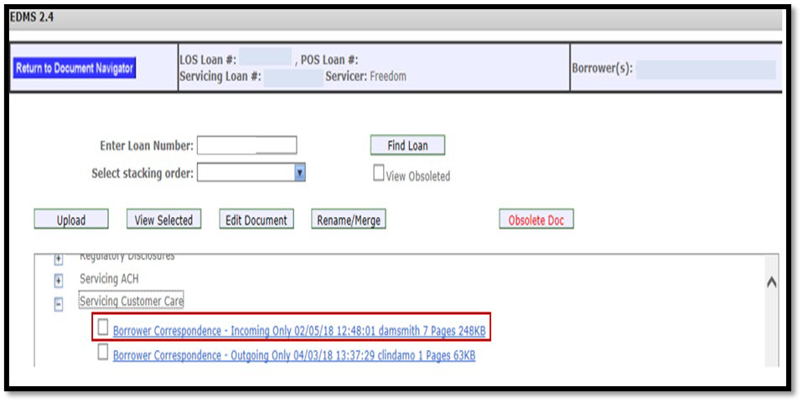

* + - * 1. C&R will open **CIT 729** to request payment of the supplemental tax bill.

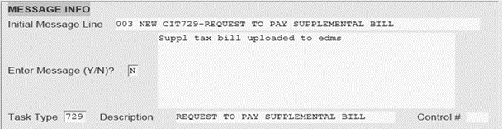The turnaround time for this request is 5-7 business days.

***Note:*** Use of incorrect CITs can cause a delay of payment which can result in a penalty that will be charged to Customer Service/C&R.

DIS/NOTE will reflect all actions taken by C&R.

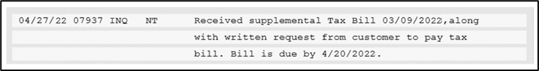

Our tax service vendor, CoreLogic, will complete the request and disburse funds to the tax agency.

CoreLogic will request a new analysis if the disbursement is over

$1,000.00 via **CIT 273** to capture the tax disbursement and new assessed value.

# Supplemental Tax Bills

* + 1. Some states/counties may send an additional tax bill that needs to be paid within the stated time.
       1. CA and NY frequently send Supplemental Tax bills.
    2. Since this is in addition to the scheduled taxes due, we do not escrow for this item.
    3. It is typically the responsibility of the homeowner to pay this bill, but there are instances where we have been collecting for the anticipated increase of the taxes.

# California Supplemental Tax – Discussion and Information

* + 1. The word “supplemental” means in addition to.
    2. Supplemental taxes are property taxes that are in addition to the current assessment for the property.
    3. The property tax law in the state of California requires that the Tax Assessor re- evaluate the property’s worth after ownership has changed.
    4. The property taxes that a new owner will be responsible for will be based on the new assessed value of the property.
    5. Supplemental taxes are the difference between what the prior owner was responsible to pay and the new owner will be responsible to pay.

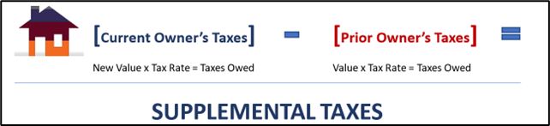

* + 1. Knowing the Law – California Civil Rule 1102.6-
       1. Disclosure requirements are governed by CA Civil Code Section 1102.6c.
       2. This rule states it is the responsibility of the Seller or their Agent to make sure that the purchaser of the property is made aware of the change in property taxes in writing.
       3. The disclosure also advises the new homeowner that their mortgage company will not be receiving a copy of the supplemental tax bill and it will be the homeowner’s responsibility to pay the supplemental taxes.

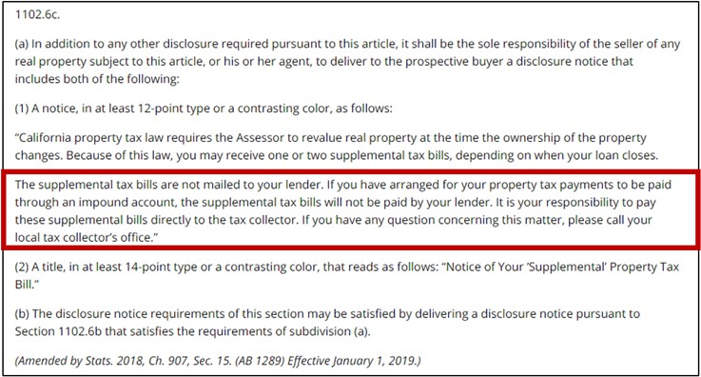

# Purchase Loans First Year’s Taxes

* + 1. The first year’s tax amounts will vary depending on when the property is purchased and how soon it can be reassessed.
       1. Many times the property will be reassessed during the same tax year that the property was purchased and the supplemental taxes will be due in that same year.
       2. In California, taxes are paid in two halves.
          1. The first half is due no later than December 10th and the second half no later than April 10th.
          2. On occasion, the property assessment will occur after taxes are due.

When this happens, the County will report the prior owner’s tax amounts as due and Freedom Mortgage will pay the due amount and the supplemental tax bills will be sent to the homeowner after the fact.

Customers may misunderstand and mistake the supplemental tax bill for a delinquent tax bill.

# Subsequent Years’ Taxes

* + 1. After the first year, the tax amount every year thereafter will be based off the newly assessed value.
       1. The total tax due will be comprised of the prior taxes and the supplemental taxes.
       2. Even though supplemental taxes are paid only once, the amount of the supplemental taxes will become part of the total annual property taxes in perpetuity.

# Supplemental Tax Estimators

* + 1. Many counties in CA provide an online method of estimating the amount of supplemental taxes that will be due in the first year.
       1. Lenders that take advantage of these estimators qualify the customer based off the total tax amount, not the current tax amount.
       2. As such, the customer begins escrowing for the purpose of having their lender pay their supplemental taxes and will not experience the same level of payment change as those who are qualified based off the current amounts.

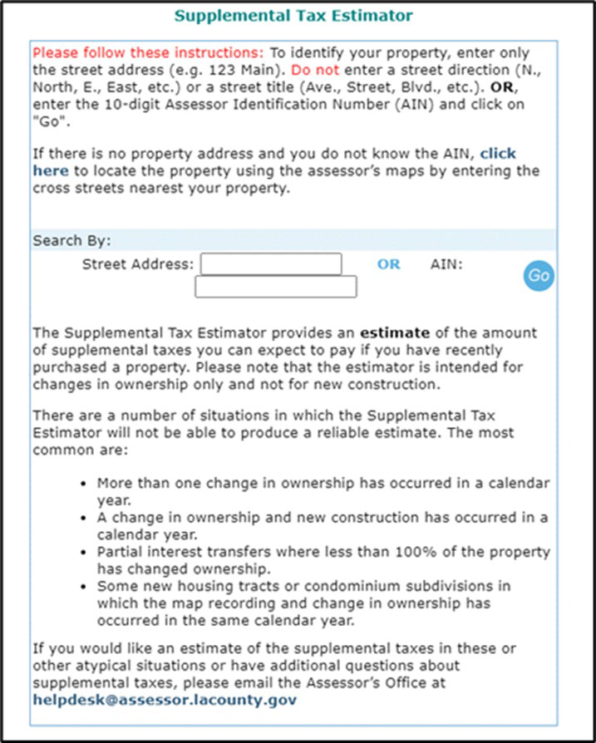

# Identifying Supplemental Taxes

* + 1. Customers may not be aware of the difference between their regular tax bill, a delinquent tax bill, and a supplemental tax bill.
       1. Before we can accurately answer the customer’s questions and provide them the correct direction and instructions, we’ll need to know which bill we are working.

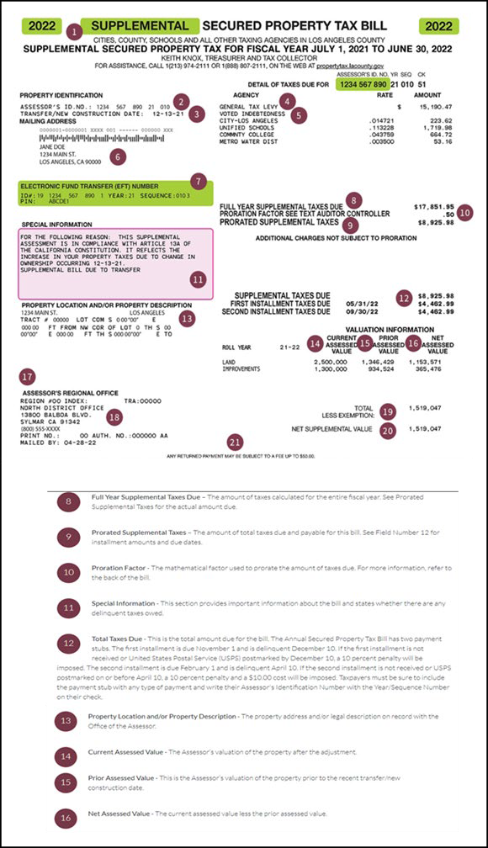

# Supplemental Taxes – Common Customer Issues

* + 1. Lender did not utilize a supplemental tax estimator-

# Option One – Customer pays the supplemental tax bill.

* + - * 1. Verify the tax amounts on the Initial Escrow Analysis Statement (IEAS) are not higher than the amounts on Schedule B from the Title Commitment.
        2. Advise the customer supplemental taxes are the responsibility of the homeowner and tax amounts are not reported to FMC leaving FMC unable to pay the taxes.
        3. Educate the customer that the supplemental taxes will become part of the annual taxes moving forward and the increased amount will cause the annual escrow to increase and may cause a shortage in their escrow account when it is next analyzed.

# Option Two - Customer asks Freedom Mortgage to pay taxes and creates a shortage.

* + - * 1. Verify the tax amounts on the IEAS are not higher than the amounts on Schedule B from the Title Commitment.
        2. Advise the customer supplemental taxes are the responsibility of the homeowner and tax amounts are not reported to FMC leaving FMC unable to pay the taxes.
        3. If this will cause a hardship or the homeowner is unable to pay the supplemental taxes, ask them to send a request in writing for Freedom Mortgage to pay the taxes along with a copy of the supplemental tax bill.
        4. Inform the customer that because Freedom Mortgage is making an unanticipated disbursement from the escrow account, this will cause a shortage when it is next analyzed.
        5. Educate the customer that the supplemental taxes will become part of the annual taxes moving forward and the increased amount will cause the annual escrow to increase along with the shortage.
        6. There is no need to open a CIT to pay the supplemental taxes.

When C&R receives the written request and tax bill, they will open the CIT for CoreLogic to pay the supplemental taxes.

* + 1. Lender did utilize a supplemental tax estimator-

# Instance One - Tax assessment was completed prior to escrow analysis.

* + - * 1. Verify the tax amounts on the IEAS are higher than the amounts on Schedule B from the Title Commitment.
        2. Advise the customer supplemental taxes that Freedom Mortgage has been collecting for their supplemental taxes and they should not be paid out of pocket.
        3. Let the customer know that supplemental tax amounts are not reported to Freedom Mortgage because typically they are the responsibility of the homeowner.
        4. Ask the customer to send a request in writing for Freedom Mortgage to pay the taxes along with a copy of the supplemental tax bill.
        5. Educate the customer that the supplemental taxes were an estimate and there may be a change in the escrow payment during the next analysis.

This may cause a shortage or surplus.

* + - * 1. There is no need to open a CIT to pay the supplemental taxes.

When C&R receives the written request and tax bill, they will open the CIT for CoreLogic to pay the supplemental taxes.

# Instance Two – A surplus was sent but the payment amount stayed the same.

* + - * 1. The tax assessment was not completed prior to escrow analysis, which is why the customer received an escrow surplus but their payment amount will not be changed.
        2. Advise the customer supplemental taxes that Freedom Mortgage has been collecting for their supplemental taxes, however, their property has not been reassessed.
        3. Inform the customer that Freedom Mortgage is unable to keep funds in excess of $50 over the required minimum balance.
        4. Let the customer know that they will be receiving a supplemental tax bill, and they should hold on to the surplus funds to pay that tax bill.

Now that the funds have been disbursed from the escrow account, Freedom Mortgage will no longer have the funds available to pay the supplemental taxes.

* + - * 1. Educate the customer that future tax bills will include the supplemental tax amount which is why Freedom Mortgage will continue escrowing for

the full amount of what is expected to be due, despite the property is not being assessed.

In addition, the supplemental taxes were an estimate and there may be a change in the escrow payment during the next analysis.

This may cause a shortage or surplus.

|  |  |
| --- | --- |
| **Supplemental Taxes Frequently Asked Questions (FAQ)** | |
| **I have a fixed rate; doesn’t that mean my payment can never change?** | * Fixed rate mortgages apply to the principal and interest portion of the payment only. As annual tax and/or insurance amounts change, the escrow portion of the payment will also change. The first page of the Closing Disclosure Form does indicate which amounts are subject to   change over time. |
| **Why didn’t anyone tell me that my taxes were going to go up after the first year?** | * State law requires that the Seller or their Agent provide a notice regarding the reassessment of the property. |
| **My taxes are escrowed, why weren’t the supplemental taxes included in my impound account?** | * The Disclosure provided by the Seller specifically states that the supplemental tax bills are not sent to the lender and it is the responsibility of the homeowner to pay the supplemental tax bills themselves. Freedom Mortgage, however, will advance the funds for   supplemental tax bills to avoid any hardship for our homeowners. |
| **Will I only have to pay supplemental taxes once?** | * Yes and no. The taxes will only be labeled as supplemental once, however, the amount of the supplemental taxes be included in your   annual tax bill each year moving forward. |
| **Why is the shortage amount higher than the supplemental tax bill I asked for Freedom Mortgage to pay?** | * The shortage amount is the difference between the lowest anticipated escrow balance during the next 12 months and the required minimum balance. As the total of the anticipated disbursements increase, so too can the required minimum balance, which is typically 1/6 of the annual disbursements. The difference between the initial required minimum and the current required minimum would be in addition to the supplemental   taxes paid on the customer’s behalf, making the total shortage higher than just the amount of supplemental taxes that were paid. |
| **Why didn’t FMC/my originating lender begin escrowing for supplemental taxes at closing?** | * The estimated tax amounts for your property may not have been available at the time the tax certification was being completed. This would have left FMC/your lender unable to calculate the new tax   amounts. |
| **Freedom Mortgage sent a large escrow surplus, what happens if I no longer have those funds?** | * If it will cause a hardship, the customer can request for their lender to pay the supplemental taxes in writing. The unanticipated disbursement from the escrow account will cause a shortage. The shortage will   increase the monthly payment until it is cured. |

# Real Estate Taxes

* + 1. The property taxable percentage is determined by the Tax Assessor, a publicly appointed official for that jurisdiction.
       1. A Tax Appraiser determines the assessed value of the property.
       2. The assessed value is then multiplied by the tax percentage established in the local area to determine the property tax amount.
       3. The taxable amount due is unique to that property.
    2. Real Estate taxes due on a property may include County, City, School, and/or special assessments.
       1. Taxes are calculated annually with various due dates.
       2. Due dates are determined by the respective taxing authority.
       3. Some jurisdictions may offer a reduced amount or discount if paid early, by a date they have determined.
       4. A tax bill will show the amount due along with the date that the bill is to be paid.
    3. Bills must be paid by the Economic Loss Date (ELD) to avoid penalties or additional fees or to take advantage of a discounted period that may be available.
       1. If a tax remains unpaid, a tax lien may be placed on the property.
          1. Tax liens supersede any other lien on the property, including a mortgage.
    4. A life of loan tax contract is purchased with a Tax Service vendor at the time the loan is originated in order to ensure that real estate taxes are paid on the property, regardless of whether the loan is escrowed or not.

# Property Tax Exemptions

* + 1. Although a property is assessed, not all of it may be taxable.
       1. Some properties, such as those owned by religious organizations or governments are completely exempt from paying property taxes.
       2. Others are partially exempt, such as veterans who qualify for an exemption on part of their homes, and homeowners who are eligible for the School Tax Relief (STAR) program.
    2. Never advise a customer they qualify for a tax exemption.
       1. Customers will need to check with the tax assessors to determine what exemptions are available in their community and how to go about filing for an exemption.
    3. These are some of the most common property tax exemptions:
       1. STAR (School Tax Relief)
       2. Senior citizens exemption
       3. Veterans' exemption
       4. Exemption for persons with disabilities
       5. Exemptions for agricultural properties
    4. If the customer has received a tax exemption approval, advise the customer to submit their Approval Letter for processing.
       1. When the information is received and is sufficient for us to update the loan, C&R will open a CIT to the Tax Department and the tax line will be updated to reflect the exemption.
          1. An analysis will be generated to adjust the payment within seven business days of the tax line being updated.
       2. An application or notice of receipt of the application is not sufficient.
          1. The Tax-Exempt Incomplete Letter (LID 3.93) will be sent by C&R when we need the homeowner to provide official approval to determine if a homeowner is fully/partially exempt.

# Tax Line Information

* + - 1. The TAX/ITEM screen shows the tax exemption information, percentage, and exception year.

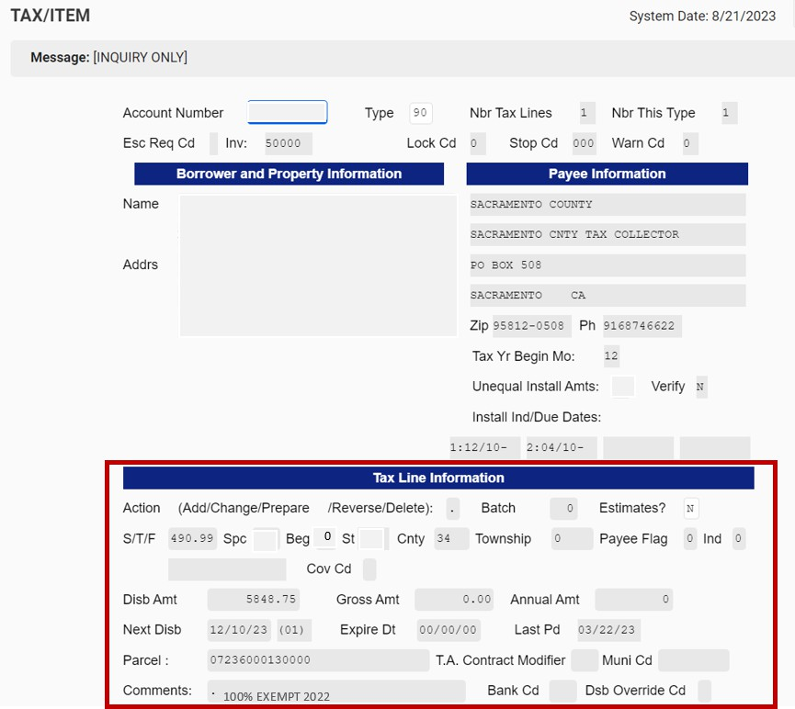

# EDMS/Servicing Customer Care

* + - 1. Below is an example of an Approved Tax Exception letter the customer will need to forward Freedom Mortgage.

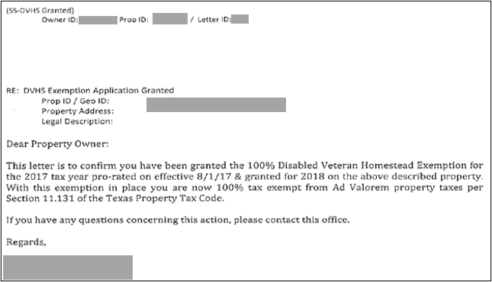

# Escrowed loans

* + 1. The Real Estate Settlement Procedures Act (RESPA) requires Freedom Mortgage to establish processes to ensure taxes are paid timely so as to avoid incurring penalties.
       1. One or more tax bills may be due on a property.
       2. Each tax bill type will have a separate line set up on the loan.
       3. Each line will include the parcel ID, next due date and last known tax amount due or paid.
    2. It is not necessary for the customer to forward tax bills to us.
       1. We will attempt to obtain the bill directly from the tax collector.
       2. Supplemental tax bills are sometimes issued in addition to the yearly real estate tax bills and are the homeowner’s responsibility to pay.
          1. They are not collected through the escrow account.
    3. If the customer receives a delinquent tax notice for a tax bill that is the responsibility of Freedom Mortgage to pay, it is important that the bill be directed to the Tax Department for research.
       1. Any penalties or loss of discount will not be charged to the customer.

# Non-escrowed loans

* + 1. It is the customer’s responsibility to pay their real estate taxes when they do not have an escrow account.
       1. The customer is in default of their loan agreement if they do not pay their taxes by the due date.
    2. The Tax Service vendor obtains delinquent tax information directly from the taxing authorities.
       1. This may include water or sewer charges that the municipality charges directly to the homeowner that remain unpaid.
       2. Delinquent bills are reported by the tax office on escrowed loans, as well.
    3. If a notification of a delinquent tax or other alienable bill is received, a letter is sent to the customer requesting proof that the delinquent amount was paid.
       1. If proof of payment is not received, funds are advanced to cure the delinquency, including all penalties and interest that have been incurred on the past due amount.
       2. An escrow account is set up to repay the amount advanced as well as collect for the payment of future taxes.
       3. The account will be analyzed, and an escrow payment will be added to the customer’s monthly payment.
    4. Once a non-escrowed loan is converted to escrow due to remitting delinquent taxes, they are unable to cancel their escrow account.

# CA Special Proposed Tax

* + 1. This tax is regarding a circumstance when the homeowner has taken out a loan with their County.
       1. Generally, these taxes are payment for energy bills like solar panels and this is considered a “loan” with the county.
    2. If a customer calls and asks you about the special tax and would like to know if we have paid the bill, go to the Dis/Check screen and the disbursement will have a transaction code of **M85**.

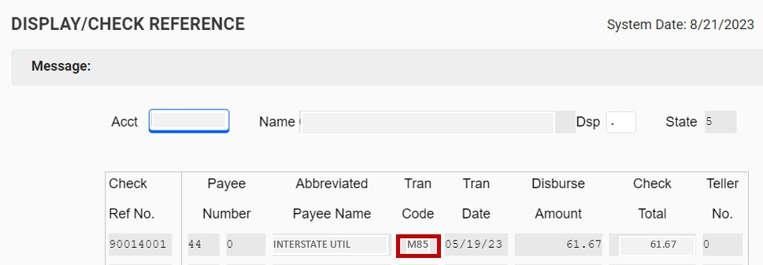

# Sending in Bills/CITs

* + 1. At this time, the customers do not need to send in the bill unless they receive a delinquency notice.

***Note:*** If customer receives a delinquent tax notice, have them forward to C&R.

**Fax#:** 817-826-0410

# Mail:

Freedom Mortgage PO Box 22670

Rochester, NY 14692

**Message Center:** Login to FreedomMortgage.com and navigate to the Message Center.

* + 1. There is no need to open **CIT 729** to have the tax item added.
       1. This will be a manual disbursement.

# Cook County, IL COE (Certificate of Error)

* 1. **Purpose:** How to handle a call when a Customer receives a letter about lower tax amounts.
  2. **Summary:** Cook County reports a tax amount to our Tax Department; however, by the time a payment is received by Cook County, an updated property assessment may have occurred, resulting in lower overall taxes owed.
     1. During this time, the customer/homeowner receives notification in the mail stating they are eligible to have their tax amounts lowered.
     2. The letter the customer/homeowner receives is informational.
        1. We are obligated to pay the full amount initially provided to Freedom Mortgage from the escrow account.
     3. The customer/homeowner does not have to take any action as their property will be presented to the Cook County Circuit Court for approval to lower the tax amount.
     4. The lowered rate provided in the notice is not official until it is approved through the Cook County Circuit Court.
     5. Once the approval is provided by the Circuit Court, the refund will automatically be sent to Freedom Mortgage.
     6. Once funds are received, they will be placed back in the escrow account and the account will be re-analyzed to reflect the new amount.

# Cook County COE – FAQs

**Q.** When will my property tax amount change once the circuit court approves the reduction in taxes?

**A.** The Cook County Circuit Court will send any over-payment back to Freedom Mortgage, at which time the Escrow Department will re-analyze the account and update the tax amount.

**Q.** Will I get a refund if there is an adjustment made?

**A.** Once we have received the refund, the Escrow Department will re-analyze the account and send any overage back to the customer greater than $50.00.

# South Carolina (SC) Tax Refunds

* 1. SC homeowners are billed at a 6% tax rate; however, they do provide a 2% tax discount to homeowners who are residents of the state.
     1. When a new loan is made, the homeowner must notify their Tax Collector that they reside in the state of SC.
        1. The Tax Collector will then adjust their tax rate to 4%.
  2. SC taxes are paid by Freedom Mortgage in December each year
  3. Annual escrow analysis for all SC loans is performed in February each year. ***Note:*** Some SC customers have provided proof of residency in SC after their taxes were paid and have received a refund for their tax adjustment. In order for Freedom Mortgage to adjust their tax payment due and escrow payment, we need them to send us their revised tax bill.

# Wisconsin (WI) Escrow Option Letter

* 1. Customers with properties in the state of WI can elect to have the tax payment check drawn from their escrow account to be sent to them, in order for them to make payment directly to their tax collector.
     1. FHA, VA and USDA loans, as well as delinquent loans, are not provided these options.
  2. If one of these customers calls, explain: “Your loan type requires us to pay your taxes directly to your tax authority. We apologize the inconvenience, but you may disregard the notice.”
  3. You may receive calls from customers concerning these checks.
     1. Below are the most common areas of concern:

# When will the check be sent?

“WI Tax checks are scheduled to be sent out for customers who elected to have the payment check sent to them directly. We have to send the payments by the 20th for customers that select this option.”

# To whom is the check payable?

“The check will be payable to our Mortgagor(s) and the Taxing Authority.”

# The check I received for my taxes isn’t enough. When are you going to send the rest?

“Escrow disbursements for taxes are based on the prior year assessment of your property. You are provided all the escrowed funds in your account for taxes. Unfortunately, we do not have any additional funds to disburse. You can remit the additional amount directly to your tax collector.”

# How do I prove I paid the taxes? What happens if I do not prove the taxes were paid?

“Our customer must send a paid receipt with their “Loan Number” back to Freedom Mortgage by March 31st unless ”

* + - * 1. If March 31st falls on a Sunday, the customer will need to send it in by the next business day.

***Example:*** Since March 31, 2019, falls on a Sunday and it is not a business day, we will accommodate and allow until April 1st to be the cutoff.

* + - * 1. If they do not, they may forfeit their option to receive future tax payment checks.
        2. Additionally, customer will need to return the “Tax Escrow Option Notice” see example below.

(1) We will include a pre-paid postage envelope with the letter to make it easy for the customer.

* + - 1. A copy of the paid receipt should be sent to:

**Fax:** 817-826-1258

**Email:** [paymentproof.dfw.tx@corelogic.com](mailto:paymentproof.dfw.tx@corelogic.com)

# Mail:

Delfus Department

P.O. Box 9203

Coppell, TX 75019-9210

* + - 1. The following is a sample of the letter that will accompany a copy of the tax escrow option notice:

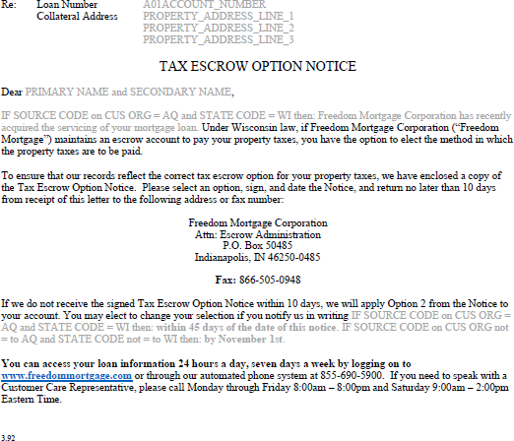

* + - 1. The following is a sample of the letter that will accompany the check:

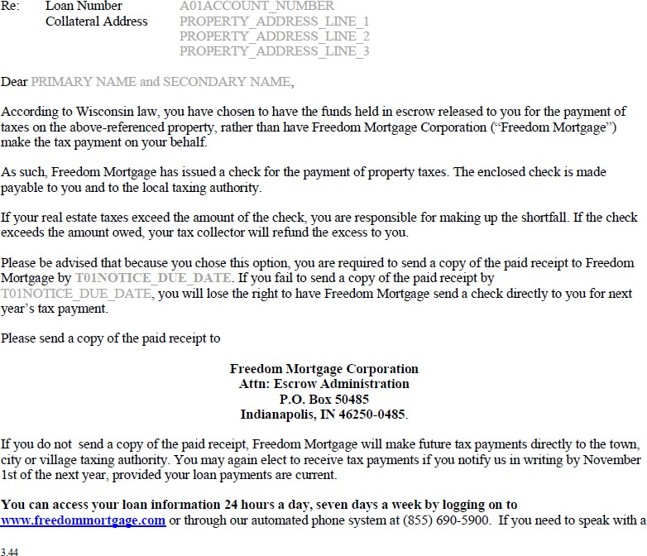

# Tax Bill – Common Customer Questions

|  |  |
| --- | --- |
| **Tax Bills FAQ** | |
| **I received my most recent tax bill from my county and I need to send you the bill.** | * First ask the customer what the tax bill represents; is the tax bill a current bill, delinquent notice, supplemental tax bill, or an installment adjustment. * Next check to see if property taxes are paid from the escrow account. If taxes are included as part of the escrow and it is a current tax bill, advise the following: * “Mr. Smith, it isn’t necessary for you to send us the tax bill received from your county, it’s for your information and review. Your tax assessor will issue a Tax Amount Report (“TAR”) to Freedom Mortgage which will reflect the current amount due. Freedom Mortgage will issue the payment on your behalf.” * If an escrow account is set up but taxes are not included or if the loan does not have an escrow account, review the notes in LoanServ, the initial setup of the loan and the closing documents to ensure taxes should not be included and advise the following: * “Mr. Smith, I don’t see that your loan is set up for Freedom Mortgage to pay your property taxes….” |
| **I have received a supplemental tax bill from my county and need some assistance.** | * “Mr. Smith, if this is a supplemental tax bill, it is important to note that your escrow account is not currently   collecting for that particular disbursement as this is typically a one-time bill and is your responsibility to pay.”   * If the customer states, they are unable to afford the supplemental tax payment please advise them: * “Mr. Smith, if you are unable to afford the payment, you will need to either fax or mail a copy of your tax bill to our Tax Department. The fax number to our Tax Department is 817-826-0410 or the mailing address is Freedom Mortgage P.O. Box 22670, Rochester, NY, 14692. By Freedom Mortgage making the additional tax payment on your behalf, there will be a shortage in your escrow account as the supplemental tax bill was not projected in your “Initial Escrow Account Disclosure” at the time your loan originated.” * “After we make the payment on your behalf, we will analyze your escrow account and adjust the payment to collect on the escrow shortage for advancing the funds. Any shortage that is caused by the additional   disbursement will be spread over the next twelve (12) months.” |
| **I received a letter from my tax assessor’s office regarding an adjustment to my property taxes which is lowering my payment.** | * First ask the customer if they have received the formal bill from their tax assessor confirming the new amounts. If they have not received the formal bill advise the customer, the following: * “I understand Mr. Smith that you have received a letter from your tax assessor in which they have adjusted your tax bill lowering your tax payments due and you have not received a formal bill yet. Until you receive the formal bill from your tax assessor, we will be unable to adjust the tax amounts on your loan; however, once you receive the formal bill, you can either fax or mail a copy to our Tax Department at 817-826-0410 or mail to Freedom Mortgage, P.O. Box 22670, Rochester, NY, 14692.” * If the customer has received their letter and formal bill from their tax assessor confirming the new amounts, advise the customer of the following: * “Mr. Smith, since you have received formal confirmation of your adjusted tax bill, there is no need to fax a bill to us as your tax assessor will issue a Tax Amount Report to Freedom Mortgage with the updated payment amount; however, if you would like to send us a copy of your tax bill, you may either fax or mail a copy to our   Tax Department at 817-826-0410 or mail to Freedom Mortgage, P.O. Box 22670, Rochester, NY 14692.” |
| **I have received a delinquent tax bill from my county and need to send you the bill.** | * “Mr. Smith, I apologize that your taxes are delinquent and I will open up a request with my Tax Department   to verify with your tax office the past due amount (Open **CIT 266**/Delinquent Tax Bill). So that I may include as much information in my request, can I ask the past due tax amount along with any fees and penalties on the statement to add into the request? If you could also please forward a copy of your delinquent tax bill to our Tax Department via fax to 817-826-0410 or you may mail in a copy of the bill to P.O. Box 22670, Rochester, NY 14692. Again, my apologies for the delinquent bill you have received and to confirm I have opened the request to have my Tax Department review and contact your tax office. I have an estimated completion date of (provide Target Completion Date from CIT).”  **\*\*ONLY provide the above Tax Department information when advising the customer to send in a copy of**  **their delinquent, adjusted or corrected tax bill.\*\*** |

**APPENDIX**

List of resources that may be useful when performing this process:

* ARM (Call Center) Job Aid
* Bankruptcy (Call Center) Job Aid
* Buydowns (Call Center) Job Aid
* Cinch Home Warranty Services _ Job Aid
* Customer Care (Call Center) Job Aid
* Customer Engagement Procedure
* Foreclosure Call Flow (Call Center) Job Aid
* Mobile Application (Call Center) Job Aid
* Payment Processing (Call Center) Job Aid
* Payoff Ordering Job Aid
* Roadmap to Success (Call Center) Job Aid
* SCRA and State Servicemember Protection (Call Center) Job Aid
* TransPerfect Language Line Job Aid
* Vendor Call Handling Job Aid
* Web Portal (Call Center) Job Aid
* Year-End 1098 and 1099 Statements (Call Center) Job Aid